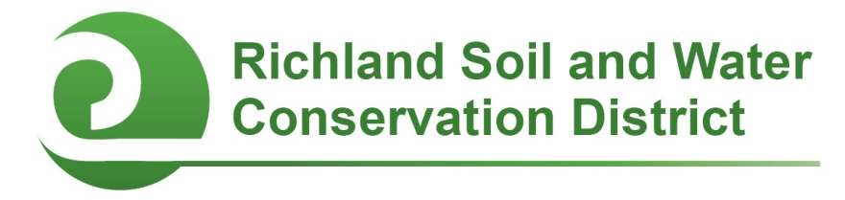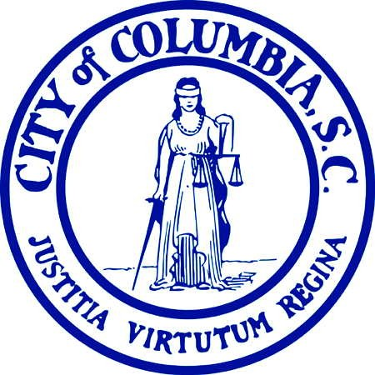
2016-2017 Conservation Education and Clean Stream Columbia
Mini-Grants

Columbia, SC--Faculty and staff members of public, private, and alternative schools in Richland County are eligible to apply for up to $500 in funding to support campus conservation projects and youth environmental education initiatives through Conservation Education Mini-Grants and Clean Stream Columbia Awards. Two award cycles are available: applications received by October 7, 2016 will be considered for fall 2016 funding; applications received by February 3, 2017 will be considered for spring 2017 funding. Project work and the expenditure of funds must be completed by June 15, 2017.

Mini-Grants may be used to support conservation-related student projects including, but not limited to, outdoor classrooms, school gardens, nature trails, wildlife habitats, rain barrels, composting initiatives, air quality campaigns, litter clean-ups, rain gardens, erosion control, and stream bank restoration. Awards are competitive and proposals will be evaluated on the project’s conservation impact, feasibility, student and community involvement, and educational outcomes.

All schools located in Richland County (including the City of Columbia) are eligible to compete for Conservation Education Mini-Grants; schools located in the City of Columbia are also eligible to compete for Clean Stream Columbia Awards for certain projects that promote, protect or improve water quality. Funding for these awards is provided by the Richland Soil and Water Conservation District and the City of Columbia. For more information, contact Chanda Cooper at (803) 576-2084 or cooperc@rcgov.us.

2016-2017 Conservation Education and Clean Stream Columbia
Mini-Grant Application

Applicant’s name and title/position:
E-mail address:
Phone #:
School:

Is the school physically located in the City of Columbia? __Yes __No
(If you are unsure, visit http://gis.columbiasc.gov/cocinfo/ and enter the school’s street address in the search box on the right side of the page. If the address is located within the City limits, a “City Information” box in the lower left-hand corner will state “Am I within the City Limit? Yes.”)

Principal’s name:
Principal’s e-mail address:
Principal’s signature: ___________________________________________________________
By signing above, I agree to allow the proposed project to be completed or installed on campus.

Please respond to the following questions. Attach additional pages if necessary.

- Project Overview: Describe the proposed project and how it promotes natural resource conservation and education.

- Project Budget:
Item | Unit Cost ($) | Quantity | Cost ($)
Total ($)

- Funding: If your project will cost more than $500 (the maximum amount of the mini-grant), how will the rest of the project be funded?

- Project timeline: Describe your project’s timeline.

- Student Involvement:
  - How many students will be involved with this project? List by grade.

  - How will students be involved with this project?

- Collaboration: Describe if and how other faculty members, staff, parents, project mentors, or community volunteers will be involved with the project.

- Educational Outcomes: How will this project enhance student learning? If appropriate, include any state or local academic standards this project will be used to address.

- Optional Supporting Materials: You are welcome but not required to submit photographs with captions, letters of support, or other materials demonstrating why your project deserves to receive a Conservation Education Mini-Grant.

Submit your application and any optional supporting materials by US Mail, E-mail, fax, or hand delivery to:

Richland Soil and Water Conservation District
2020 Hampton Street, Room 3063A
Columbia, SC 29204
Phone: (803) 576-2080
Fax: (803) 576-2088
E-mail: cooperc@rcgov.us

Application Deadlines:
October 7, 2016 and February 3, 2017

